Oscar Wilde. The Canterville Ghost

The cast
Mr.Otis – Sergey Trofimov
Mrs. Otis – Dasha Golub
Lord Canterville – Ivan Tkach
Mrs. Umney - the old housekeeper - Kristina Muradimova
The Ghost – Anastasia Aksienova
The twins –Stepan Parfenchik, Kirill Chifurov
Virginia – Alexandra Beliak

Scene 1

Act1

Slide 1 Sound 1.Church bell

Slide 2,3 Sound 2. Crow cries

Mr.Otis

Slide 4 Sound 2. Crow cries

-That is the place we are going to live! It is a real beauty!

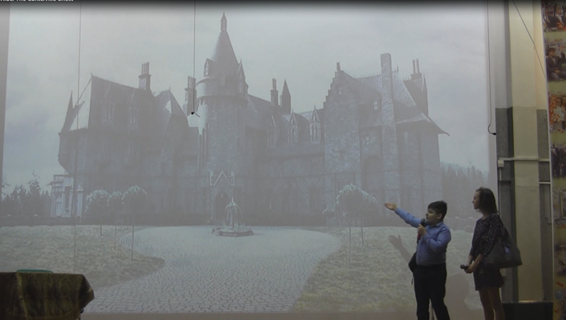

Slide 5
Lord Canterville
- It is my duty to tell you We have not cared to live in the place ourselves. My grand-aunt, the Duches of Bolton, was frightened into a fit, from which she never really recovered, by two skeleton hands being placed on her shoulders as she was dressing for dinner, and I feel bound to tell you, Mr. Otis, that the ghost has been seen by several living members of my family. Lady Canterville often got very little sleep at night, because of the mysterious noises that came from the corridor and the library.

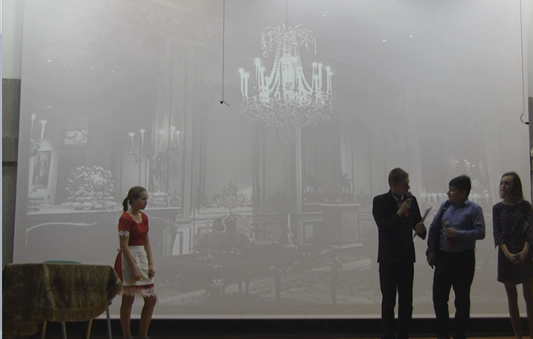

Sound 3 Evil laughter

Slide 6

Mr. Otis

-My Lord, I will take the furniture and the Ghost. I come from a modern country, where we have everything that money can buy.
I believe that if there were such thing as a ghost in Europe, we'd have it at home in a very short time.

Lord Canterville
-I fear that the ghost exists. (Smiling)It has been well known for three centuries, since 1584 in fact, and it always makes its appearance before the death of any member of our family.

Mr.Otis

-Well, so does the family doctor for that matter, Lord Canterville. But there is no such thing, sir, as a ghost.

Lord Canterville
-You are certainly very natural in America, and if you don't mind a ghost in the house, it is all right. Only you must remember I warned you.

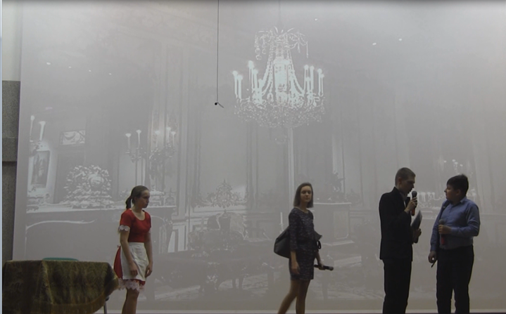
Act 2

Slide 7
(looking around Mrs. Otis catches sight of dull red stains on the floor just by the fireplace and, quite unconscious of what it really signifies, addresses to Mrs. Umney)

Mrs. Otis
-I am afraid something has been spilt there.

Mrs. Umney - the old housekeeper
-Yes, madam, blood has been spilt on that spot.

Mrs. Otis
-How horrid, I don't at all care for blood-stains in a sitting room. It must be removed.

(The old woman smiles, and answers in the same low, mysterious voice)

Mrs. Umney - the old housekeeper
-It is the blood of Lady Eleanore de Canterville, who was murdered on that very spot by her own husband, Sir Simon de Canterville, in 1575. Sir Simon survived her nine years, and disappeared suddenly under very mysterious circumstances. His body has never been discovered, but his guilty spirit still haunts the castle. The blood-stain has been much admired by tourists and others, and cannot be removed.

Sound 3 Evil laughter

Mr. Otis
-That is all nonsense. Pinkerton's Champion Stain Remover and Paragon Detergent will clean it up in no time.

(he falls upon his knees. In a few moments no trace of the blood-stain is seen).

Slide 8
-I knew Pinkerton would do it.

Sound 4 Thunder

(He exclaims triumphantly, as he looks round at his admiring family. A terrible flash of lightning lights up the somber room, a fearful peal of thunder makes them all start to their feet, and Mrs. Umney faints).

Mr. Otis
-What a monstrous climate!

Mrs. Otis
-My dear Hiram, what can we do with a woman who faints?

Mr. Otis
- Charge it to her like breakages, she won't faint after that.

(In a few moments Mrs. Umney certainly comes to. There
is no doubt, however, that she was extremely upset, and she sternly warns Mr. Otis to beware of some trouble coming to the house).

Mrs. Umney- the old housekeeper
-I have seen things with my own eyes, sir, that would make any Christian's hair stand on end, and many and many a night I have not closed my eyes in sleep for the awful things that are done here.

-Beware of some trouble coming to the house.

Sound 5 Rain with thunder

Scene 2
Act 1

Slide 9

Sound 6 Chains
(The storm is raging fiercely all the night. The ghost is painting the blood stains. Mr. Otis is awakened by a curious noise in the corridor, outside his room. It sounds like the clank of metal. He puts on his slippers, and opens the door. Right in front of him he sees, an old man with long grey hair falling over his shoulders and from his wrists and ankles are hanging heavy rusty chains).

Mr. Otis
- My dear sir, I really must insist on your oiling those chains, and I have brought you for that purpose a small bottle of oil. I shall leave it here for you and will be happy to supply you with more, should you require it.

(With these words Mr. Otis lays the bottle down on a marble table, and, closing his door, retires to rest. For a moment the Canterville ghost stands quite motionless in natural indignation; then, dashing the bottle violently upon the polished floor.

The Ghost
-It is quite unbearable. It is quite unbearable.

Act 2
Mr. Otis (to twins)
-I have no wish to do the ghost any personal injury, and I must say that, considering the length of time he has been in the house, I don't think it is polite to throw pillows at him.

(Picks up the pillows)

Act 3

Sound 8 Clock ticking
Mrs. Otis
-I am afraid you are far from well, and I have brought you a bottle of medicine. If it is indigestion, it is an excellent remedy.

(The ghost is glaring at her in fury and begins to moan).

Scene 3
Act 1
(Virginia on returning home makes up her mind to go up by the back staircase so as not to be seen. As she is running past the Tapestry Chamber, the door of which happens to be open, she sees to her immense surprise, however, the Centerville ghost himself! He is sitting by the window. So light are her footsteps, and so deep his melancholy, that he is not aware of her presence till she speaks to him).

Virginia
-I am so sorry for you, but my brothers are going back to Eton tomorrow, and then, if you behave yourself, no one will annoy you.

The Ghost
-It is absurd asking me to behave myself.

-Quite absurd. I must rattle my chains, and walk about at night. It is my only reason for existing.

Virginia
-It is no reason at all for existing, and you know, you have been very wicked. Mrs. Umney told us, the first day we arrived here, that you had killed your wife.

Virginia
-It is very wrong to kill anyone.
- Mr. Ghost, I mean Sir Simon, are you hungry? I have a sandwich in my case. Would you like it?

The Ghost
-No, thank you, I never eat anything now; but it is very kind of you, all the same, and you are much nicer that the rest of your horrid, rude, vulgar, dishonest family.

Virginia
-Stop!
(Virginia, stamps her foot)

-It is you who are rude, and horrid, and vulgar, and as for dishonesty, you know you stole the paints out of my box. First, you took all my reds, then you took the green and the yellow, and finally I had nothing left. I never told on you, though, I was very much annoyed.

The Ghost
-Well, really, what was I to do? It is very difficult to get real blood nowadays.

Virginia
-Good evening, then, Mr. Ghost

The Ghost
-Please don’t go, Miss Virginia. I am so lonely and so unhappy, and I really don't know what to do. I want to go to sleep and I cannot.

Virginia
- You cannot sleep? That's quite absurd! You have to go to bed and blow out the candle.

The Ghost
-I have not slept for three hundred years, and I am so tired.

Virginia
-Poor, poor Ghost, have you no place where you can sleep?"

Slide 10
Sound 8 Wind

The Ghost
-Far away beyond the pine woods, there is a little garden. There the grass grows long and deep, there are the great white stars in the sky. The nightingale sings all night long.

(Virginia's eyes grow dim with tears, and she hides her face in her hands).

Virginia
-You mean the Garden of Death?
(she whispers)

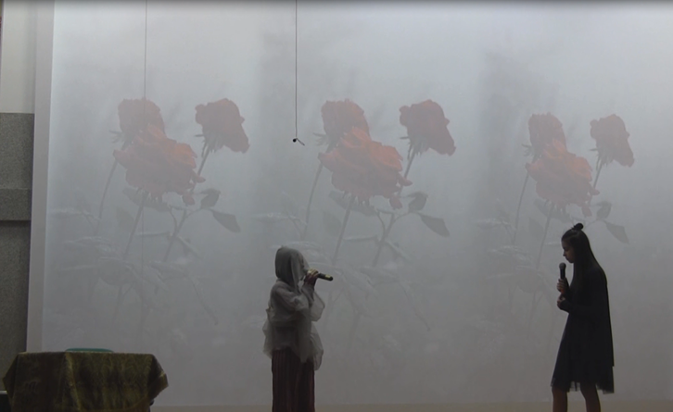

Slide 11
Sound 10 Crow cries

The Ghost
-Yes, Death. Death must be so beautiful. You can help me, for Love is always with you, and Love is stronger than Death is.

-Have you ever read the old prophecy on the window?"

Slide 12

Virginia
-Oh, often, I know it quite well.
WHEN A dark- haired GIRL CAN WIN
A PRAYER FROM OUT THE LIPS OF SIN,
WHEN THE BARREN ALMOND BEARS,
AND A LITTLE CHILD GIVES AWAY ITS TEARS,
THEN SHALL ALL THE HOUSE BE STILL
AND PEACE COMES TO CANTERVILLE.

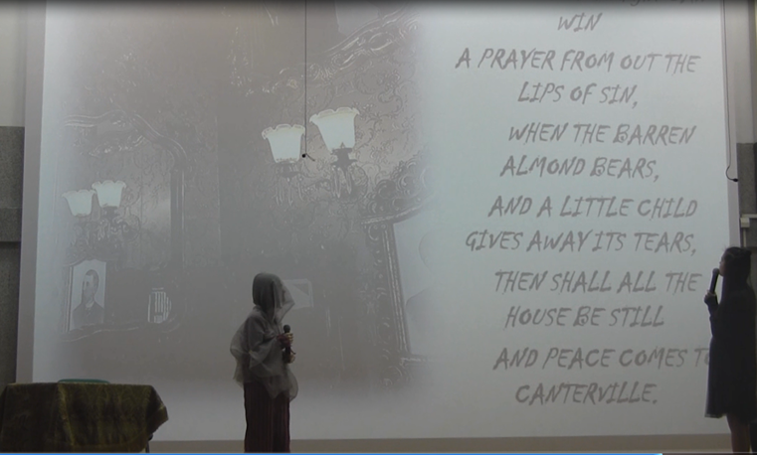

Sound 11. Fairy tale

But I don't know what they mean.

The Ghost
-They mean, you must weep with me for my sins, because I have no tears, and pray with me for my soul, because I have no faith, and the Angel of Death will have mercy on me.

(Virginia suddenly she stands up, very pale)

Sound 12. Clock strikes

Virginia
-I am not afraid; I will ask the Angel to have mercy on you.

Приведение обнимает Вержинию и берет за руку
(He kisses her hands).

The Ghost
-Quick, quick

Scene 4

Act1

Slide 13

Sound 12.Sound of the Church Bell
(About ten minutes later, Mrs. Otis rings the bell for tea and, as Virginia does not come down. Mr. Otis searches every room in the house. Midnight begins to boom from the clock tower, and when the last strikes sounds they hear Virginia appear. In a moment they all rush up to her. Mrs. Otis clasps her passionately in her arms.)

Mr. Otis
-Good heavens, child, where have you been? I have been looking for you, and your mother has been frightened to death. You must never play these jokes anymore.

Mrs. Otis
-My darling, thank God you are found; you must never leave my side again.

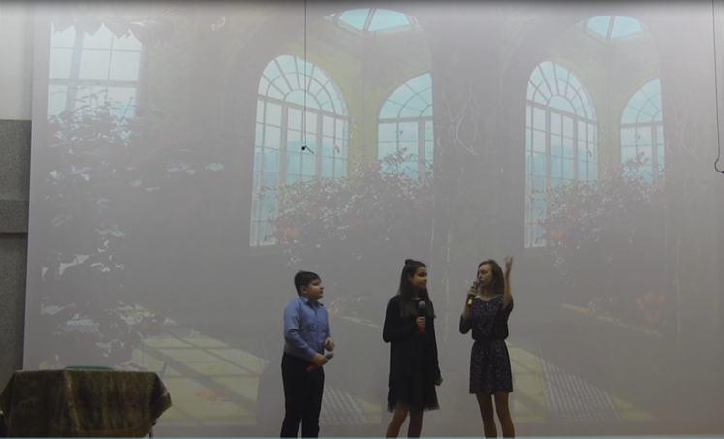

Virginia
-Papa, I have been with the ghost. He is dead now. He was really sorry for all he had done, and he gave me this box of beautiful jewels before he died.

(All together)

-God has forgiven him.

Slide 14

